
Lebanese University
Faculty of Engineering III
Electrical and Electronic Department

______________________

Pseudo-3D Holographic Retro Racing Engine on the ESP32 Platform
Communication and Mini-Project

by
Mohamad Issa, 6783
Imad AlBekai, 6683
______________________

Spring 2025-2026

______________________
Supervisors: Dr. Rida Chall, Dr Abed Ellatif Samhat

DEDICATION

This report is dedicated to my family, whose patience and encouragement made this project possible, and to everyone who believes that meaningful engineering begins with curiosity and the willingness to keep debugging until the circuit finally works.
Acknowledgment
I would like to express my sincere gratitude to Dr. Rida Chall and Dr. Abed Ellatif Samhat for their guidance, feedback, and continuous support throughout the Communication and Mini-Project course. I am also grateful to the Electrical and Electronic Department at the Lebanese University, Faculty of Engineering III, for providing the laboratory resources and technical environment that made the design, assembly, and testing of the Game Console System possible.
Abstract

This project presents the advanced design and implementation of a 3D perspective retro racing game, integrated into a custom-built arcade cabinet that utilizes a "Pepper’s Ghost" holographic illusion. The system features a pseudo-3D rendering engine optimized for a resource-constrained ESP32 microcontroller, outputting to a 2.4-inch TFT display via a high-bandwidth 8-bit parallel interface. By positioning the display beneath a 4mm glass pane at a 45-degree angle, the project achieves a convincing depth-based holographic effect. The software architecture leverages the Arduino_GFX library and a custom bitmap font engine designed for mirrored text rendering, ensuring visual fidelity within the reflected optical path.

The methodology employed a hardware approach utilizing the ESP32 paired with a 2.4-inch 40-pin TFT display using an 8-bit parallel interface, physical push buttons for steering and mechanics, and dual passive buzzers supporting a non-blocking audio engine. Software development involved writing a custom C++ engine leveraging the Arduino_GFX library. Key features include dynamic system for police and civilian vehicles, a nitro management system, and intricate perspective projection mathematics to convincingly simulate a 3-dimensional environment on a 2D screen.

The obtained results successfully demonstrate a remarkably smooth, visually impressive, and highly playable embedded arcade game. The final system features escalating time-based difficulty, precise real-time collision detection, and continuous, concurrent background music, proving the viability of the ESP32 for complex retro gaming and simulation applications.

Keywords: ESP32, TFT, 8-bit Parallel, Pseudo-3D, Pepper's Ghost, Custom Bitmap Font, Arduino_GFX, Embedded Gaming.

Table of Contents

Acknowledgment ii
Abstract iii
List of Figures vi
List of Tables vii
List of Abbreviations viii
Chapter 1 Introduction 10
1.1 Background Information 10
1.2 Problem Statement 10
1.3 Objective and Motivation 10
1.4 Thesis Outline 10
Chapter 2 Literature Review 11
2.1 Introduction 11
2.2 ESP32 Microcontroller:………………………………………………………11
2.3 2.4-inch 40-pin TFT Display:…………………………………………………….11
2.4 Push Buttons:…………………………………………………………………11
2.5 Passive Buzzers……………………………………………………………….12
2.6 Summary and Design Justification……………………………………………12
Chapter 3 System Design 13
3.1 Introduction 13
3.2 System Requirements 13
3.2.1 Use Case Diagram 14
3.3 System Architecture 15
3.4 Non-Functional Requirements 16
3.5 Conclusion 17
Chapter 4 Implementation and Results 18
4.1 Introduction 18
4.2 Implementation Tools 18
4.2.1 Software Tools 18
4.2.2 Hardware Tools 18
4.3 Implementation Steps 19
4.4 Results 20
4.5 Conclusion 21
Chapter 5 Conclusion 22
5.1 Conclusion 22
5.2 Future work 22
References 23
Appendices 24
Appendix A: Core Engine Code Snippets…………………………………………………24
Appendix B: Circuit Schematic / Wiring Diagram
……………………………………...35

List of Figures

Figure 3.1: Use Case Diagram of the 3D retro car game 15
Figure ‎3.2 Hardware Architecture of the 3D retro car game…………………………….16

List of Tables

Table ‎4-1 Summary of the implementation Tools 19

List of Abbreviations

IC  AI  BGM  EEPROM  ESP32  HUD | Integrated Circuit  Artificial Intelligence  Background Music  Electrically Erasable Programmable Read-Only Memory  Espressif Systems 32-bit Microcontroller  Heads-Up Display

Introduction

Background Information
The 1980s and 1990s were golden eras for arcade racing games, utilizing pseudo-3D scaling techniques to simulate depth before true 3D hardware became widely available. Modern embedded systems, like the ESP32, possess more processing power than many retro consoles, making them excellent platforms for recreating these nostalgic gaming experiences

Problem Statement
Developing a real-time, 3D-perspective game on a microcontroller with a monochromatic 2.4-inch screen presents significant challenges. The system must concurrently handle complex mathematical projections for 3D graphics, dynamic tracking system, collision detection, and audio generation without freezing the main game loop or causing frame-rate drops..

Objective and Motivation
This is a statement of the project's goals and the reasons driving its importance. The objective is to design a standalone, handheld arcade game that seamlessly runs a 3D racing environment. The motivation stems from the desire to push the graphical and processing boundaries of the ESP32 while applying core engineering concepts such as hardware-software interfacing, state machines, and real-time computing.

Thesis Outline
Chapter 2 reviews related embedded gaming concepts. Chapter 3 details the system design and architecture. Chapter 4 covers the hardware/software implementation and results. Chapter 5 concludes the project and suggests future enhancements.

Literature Review

Introduction
This chapter provides review of existing research and technologies related to the project. It includes description and comparison of relevant theories, models, and methodologies. Classical 3D racing games historically relied on raster effects and scaling sprites (as seen in Out Run). In the context of microcontrollers, rendering true 3D polygons is often computationally prohibitive. Instead, pseudo-3D projection algorithms—which manipulate horizontal line rendering based on Z-depth—are highly effective. Furthermore, managing audio on microcontrollers usually blocks processing; thus, non-blocking timer-based approaches are necessary for simultaneous gameplay and music.

ESP32 Microcontroller:

Serving as the central processing unit (CPU), the ESP32 executes the core game loop, handles the complex mathematical projections required for 3D depth perception, and manages entity state machines. It functions by continuously processing inputs and updating the game state in real-time within its high-speed dual-core architecture, ensuring the logic runs without delays.

2.3 2.4-inch 40-pin TFT Display:
The visual interface utilizes a 2.4-inch 40-pin TFT display with a 240x320 resolution, driven by an 8-bit parallel interface via the Arduino_GFX library for superior data throughput. This display is housed within an arcade cabinet designed to facilitate a "Pepper’s Ghost" illusion. This optical effect occurs when light from the horizontally mounted display reflects off a 4mm glass pane set at a 45-degree angle, creating a transparent, floating image. To maintain performance, a custom 5x7 ASCII bitmap font engine was implemented using PROGMEM, which renders characters backward at the pixel level, bypassing the heavy computational cost of full-screen software rotation while accommodating the reflected optical path.

Push Buttons:
These physical input devices dictate player movement (left, right) and mechanics (nitro). Functionally, they are wired to the ESP32’s General-Purpose Input/Output (GPIO) pins using internal pull-up resistors. When a button is pressed, it closes the circuit to ground, pulling the GPIO pin's voltage LOW. The software continuously polls these pins to translate this physical voltage change into digital game commands.

Passive Buzzers
Used for the audio engine, the passive buzzers generate background music (BGM) and sound effects (SFX). Unlike active buzzers, they require a specific oscillating signal to produce sound. The ESP32 functions by sending Pulse Width Modulation (PWM) signals to the buzzers. By varying the frequency of the PWM signal, different musical notes and sound pitches are produced. A time-based (millis()) approach is used so these PWM signals run concurrently in the background without halting the main graphic rendering loop.

Summary and Design Justification
This project successfully implements a pseudo-3D retro racing game on an ESP32 microcontroller, utilizing a 2.4-inch 40-pin TFT display with an 8-bit parallel interface, hardware push buttons, and dual passive buzzers. To achieve a smooth, high-framerate arcade experience within a resource-constrained embedded system, several critical design choices were made: the 8-bit parallel bus was selected for superior data transfer, a pseudo-3D scaling algorithm was utilized instead of true 3D polygon rendering to minimize computational overhead, and a non-blocking, time-based audio architecture was developed to allow concurrent background music and sound effects without halting the main graphic rendering loop.

System Design

Introduction
This chapter details the comprehensive system architecture for the holographic 3D racing game. It outlines the integration of the ESP32 with a 2.4-inch TFT display and a custom-engineered optical cabinet. The design accounts for mirrored input logic—where steering controls must be logically aligned with the reflected image—and a sophisticated dual-channel audio pipeline. Non-functional requirements focus on maintaining a stable frame rate despite the increased resolution and the parallel bus management required for real-time interactivity.

System Requirements
This section outlines the detailed functional requirements of the 3D perspective retro car game from a user's perspective. It defines the necessary user interactions, the expected responses from the embedded system, and the background data processing required to maintain game logic.
User Interactions The system must register and process physical inputs from the player in real-time with minimal latency:
- Steering: The player must be able to maneuver the car left and right across the track using two dedicated push buttons. The system must restrict the player's movement within the predefined boundaries of the road.
- Nitro Boost: A third push button allows the player to engage a "Nitro" speed boost. The system must verify that the player has sufficient Nitro fuel in their reserve before activating this state.
- Game Reset: Upon reaching a "Game Over" state, the player must be able to restart the game by pressing any of the steering buttons.
System Responses The ESP32 must provide continuous, high-speed visual and auditory feedback based on the game state:
- Visual Rendering: The system must continuously render a pseudo-3D perspective of the road and scale 2D vehicle sprites (cops, civilians, and power-ups) based on their calculated Z-depth relative to the player's camera.
- Dynamic Spawning: The system must automatically generate civilian vehicles (which drift between lanes) and aggressive police vehicles (which actively track and intercept the player) based on randomized time intervals.
- Heads-Up Display (HUD): The 2.4-inch TFT display must consistently display vital player statistics, including the current Score, the Nitro fuel gauge, and the Heat (Busted) meter.
- Dynamic Audio Feedback: The system utilizes two passive buzzers. Buzzer 1 is dedicated to discrete sound effects (SFX) for collisions and power-ups. Buzzer 2 generates a rhythmic engine pulse that modulates in frequency based on the car’s velocity. As the "Heat" meter rises, this engine pulse shifts into a low-frequency suspense beat to increase player tension.
Data Processing The core game engine must handle the following logical computations in the background:
- Collision Detection: The system must continuously calculate the bounding boxes of the player and AI vehicles. If a collision occurs, the system must resolve the physics (e.g., slowing the player down or pushing them aside).
- Heat and Game Over Logic: Grinding against police vehicles must increment a "Busted Meter." If this meter reaches its maximum limit (100.0), the system must halt the game loop, trigger a specific failure sound, and display the "BUSTED" screen.
- Difficulty Escalation: The system must track the elapsed game time and linearly scale the global game speed, aggression, and spawn rates over a predefined escalation period (e.g., 4 minutes).
- Resource Management: The system must slowly regenerate the player's Nitro fuel over time and instantly replenish it if a lightning bolt power-up is collected.

Use Case Diagram
Figure 3.1 illustrates the use case diagram for the 3D retro car game, mapping the core interactions between the system's actors and its primary functions. The diagram identifies two main actors: the human Player, who directly controls vehicle steering and nitro activation, and the internal Game Engine, which autonomously manages entity spawning, difficulty escalation, and concurrent audio-visual updates. Furthermore, the diagram highlights critical internal dependencies, demonstrating how movement and entity generation continuously trigger collision calculations, which conditionally extend to affect the player's Heat meter or replenish Nitro fuel reserves.

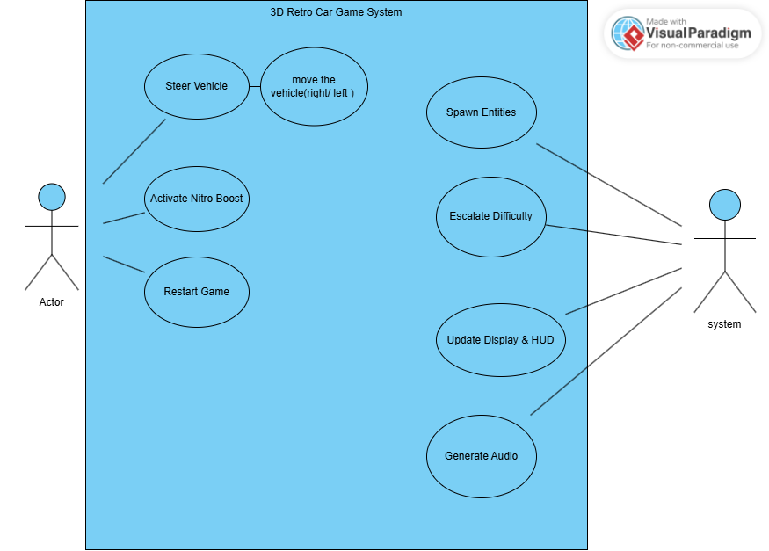

Figure 3.1: Use Case Diagram of the 3D retro car game

System Architecture
Figure 3.2 illustrates the overall system architecture, establishing the ESP32 microcontroller as the central processing unit of the game. The ESP32 collects player inputs via General-Purpose Input/Output (GPIO) pins connected to three physical push buttons that handle steering and nitro commands. Based on these inputs and the internal game engine logic, the microcontroller outputs real-time visual data to the 2.4-inch TFT display using the high-speed hardware 8-bit parallel interface protocol. Concurrently, it transmits specific Pulse Width Modulation (PWM) signals to two independent passive buzzers to generate non-blocking background music and sound effects, demonstrating a highly efficient integration of embedded hardware components.
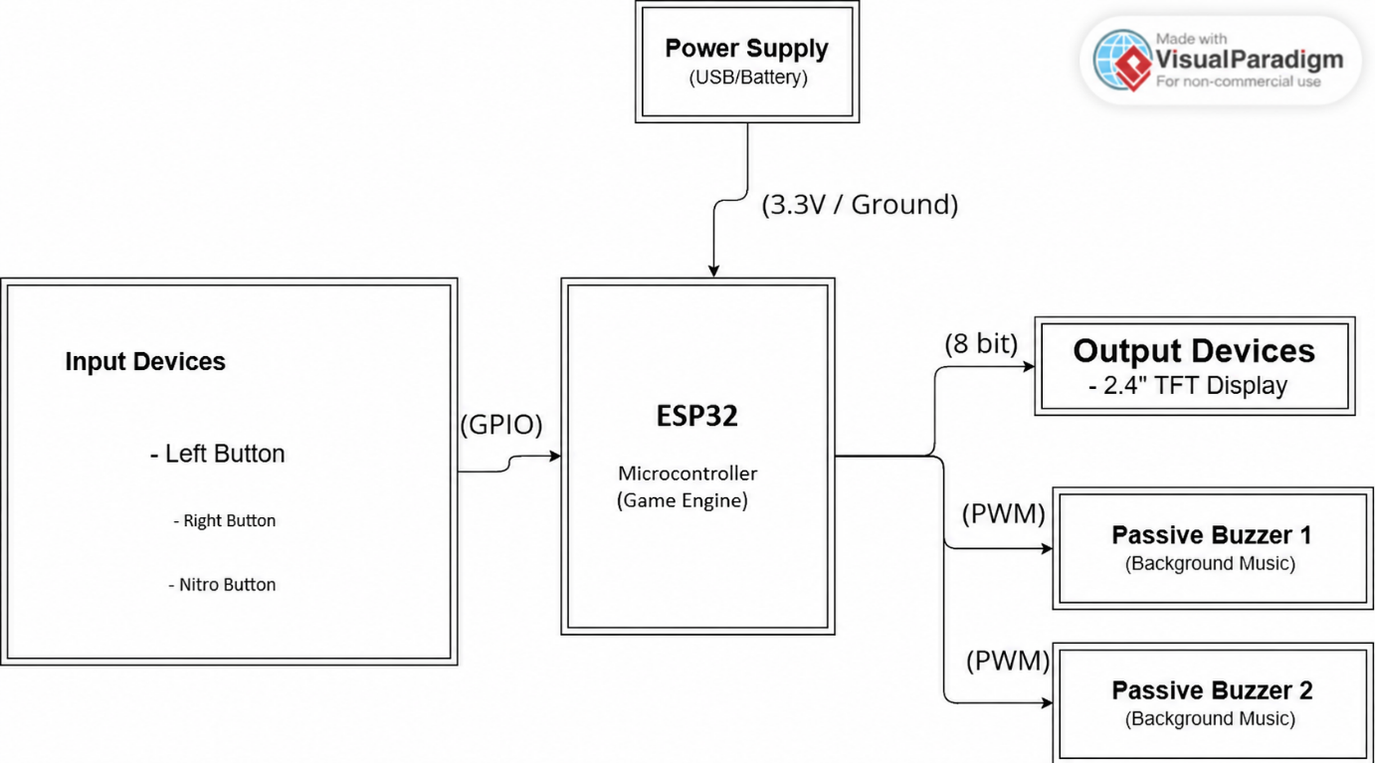
Figure ‎3.2 Hardware Architecture of the 3D retro car game

Non-Functional Requirements
This section describes the non-functional requirements that dictate the quality, performance, and operational constraints of the 3D retro car game system.
- Performance: The system must maintain a high and stable frame rate to ensure a seamless pseudo-3D visual experience. This requires highly efficient execution of mathematical depth projections and the utilization of the hardware 8-bit parallel interface protocol for 2.4-inch TFT display rendering to prevent visual lag or screen tearing.
- Reliability: The software architecture must guarantee continuous stability during extended gameplay sessions. Specifically, the concurrent processing of dual-channel audio (background music and sound effects) using time-based functions must execute reliably without blocking the main rendering loop or causing system crashes.
- Scalability: The C++ code structure must be modular and object-oriented. The entity management system should allow developers to easily introduce new game elements in the future, such as varying AI behaviors, additional power-ups, or potential network-based multiplayer features utilizing the ESP32's native Wi-Fi/Bluetooth capabilities.
- Usability: The hardware interface must be intuitive, providing immediate tactile and auditory feedback to player inputs. Furthermore, the visual Heads-Up Display (HUD) must be well-organized and legible on the small 2.4-inch screen, allowing players to easily monitor their score, heat level, and remaining nitro at high speeds.
- Stakeholders: The primary stakeholders for this system include the academic evaluators assessing the embedded design principles, future developers or students who may iterate on the open-source code, and the end-users (players) interacting with the arcade game.

Conclusion
In summary, the system design detailed in this chapter establishes a highly efficient and robust framework tailored specifically for the capabilities of the ESP32 microcontroller and the 2.4-inch 40-pin TFT display via an 8-bit parallel interface. By carefully defining the user interactions, mapping the hardware architecture, and establishing strict non-functional constraints, the system is perfectly optimized to handle the heavy computational demands of a real-time, pseudo-3D environment. This comprehensive blueprint ensures that the final implementation will deliver a responsive, stable, and immersive arcade gaming experience without overloading the embedded hardware.

Implementation and Results

Introduction

This chapter provides the implementation steps of the system. It includes details of software coding, hardware assembly, testing procedures and results. Specifically, it explores how the ESP32 microcontroller, the 2.4-inch TFT display, and the physical push buttons and buzzers were integrated to build the tangible arcade hardware. Furthermore, it outlines the software development process, detailing the C++ programming logic used to execute the pseudo-3D rendering engine, dynamic entity management, and concurrent audio systems, culminating in a comprehensive review of the final gameplay experience and system performance.

Implementation Tools
The successful implementation of this 3D retro car game required a carefully selected combination of hardware components and software development environments. The hardware was chosen to provide sufficient processing speed for pseudo-3D mathematical rendering while maintaining a compact form factor, whereas the software tools were utilized for their efficiency in compiling C++ code and driving 8-bit parallel interface-based displays.

Software Tools
• Arduino IDE: The primary integrated development environment used to write, compile, and upload the C++ game logic and engine code to the microcontroller.
• Arduino_GFX Library: A specialized graphics library used for driving TFT displays via high-speed 8-bit parallel communication, which is critical for maintaining playable frame rates at higher resolutions.
• Arduino.h Library: The core standard library required for ESP32 development within the Arduino framework. It provides access to essential embedded functions used throughout the code, such as millis() for the non-blocking audio, pinMode(), and digital I/O operations.
• 8-bit parallel interface.h Library: The standard 8-bit parallel interface library utilized to configure and establish high-speed hardware communication between the ESP32 and the 2.4-inch TFT display.

Hardware Tools
• ESP32 Microcontroller: The core processing unit responsible for executing the game loop, handling collision physics, and managing concurrent audio signals.
• 2.4-inch 40-pin TFT Module: The visual output interface where the pseudo-3D graphics and HUD are rendered.
• Push Buttons (x3): Physical tactile inputs used by the player for left/right steering and activating the nitro boost.
• Passive Buzzers (x2): Audio output devices utilized to generate separate, non-overlapping channels for background music and sound effects using PWM signals.
• 4mm Glass: Used physically within the hardware assembly to reflect the 2.4-inch TFT display, creating a deeper, arcade-cabinet style visual effect for the player.
• Black Box: Used to make Pepper’s Ghost reflection look deep inside, tricking brain by the illusion of reflection.

Table ‎4-1 Summary of the implementation Tools

Tool Type | Name | Purpose
Hardware | ESP32 | Main Processing Unit and Game Engine
Hardware | 2.4" TFT | 8-bit Parallel Interface
Hardware | Passive Buzzers | BGM and SFX Generation
Hardware | Push Buttons | Player Input Controls
Software | Arduino IDE | Code Compilation and Uploading
Software | Arduino.h | Core Embedded Functions
Software | 8 Bit Parallel | Ultra High-Speed Hardware Communication
Software | Arduino_GFX | Graphic Rendering Pipeline

Implementation Steps
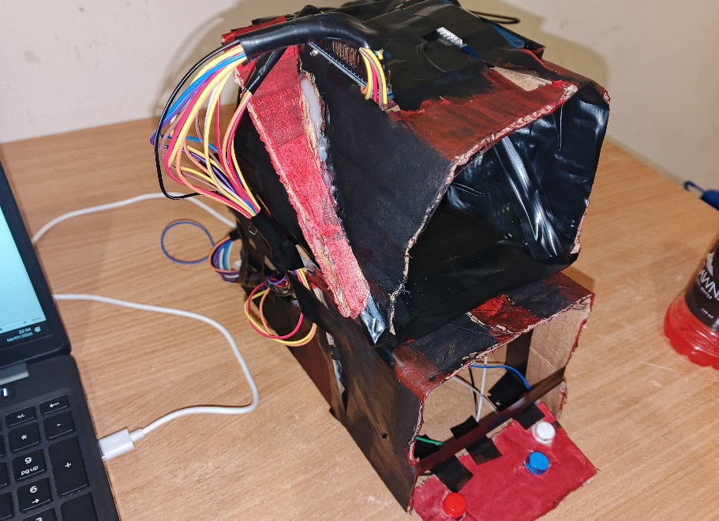
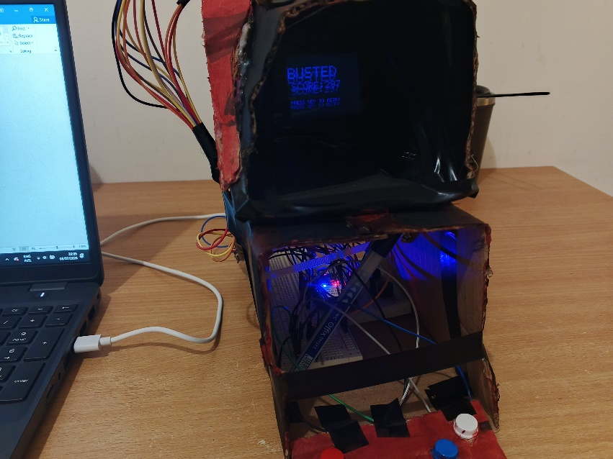
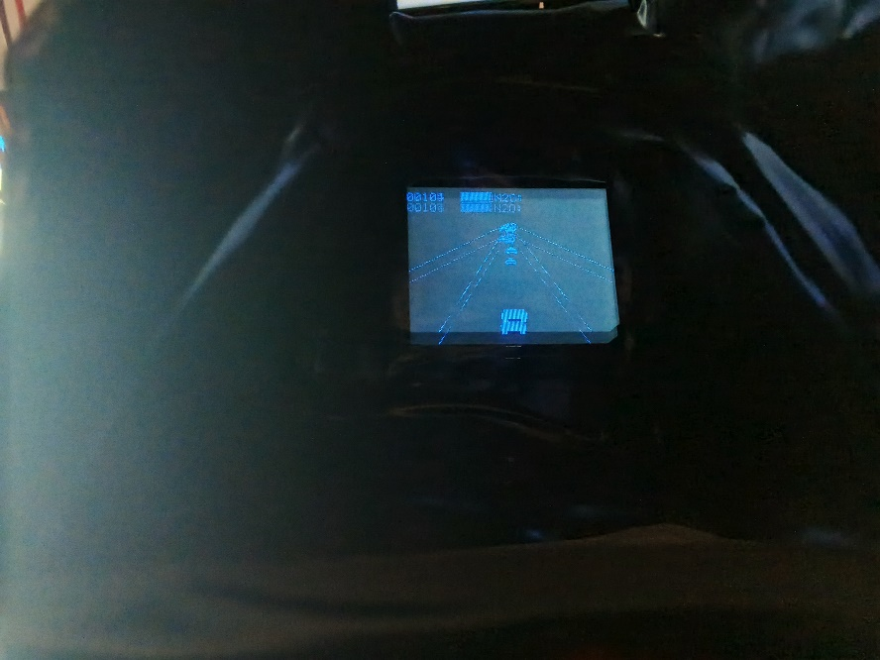
The system was developed through a systematic integration of hardware assembly and software engineering. The implementation was divided into four primary phases:
Step 1: Cabinet Assembly and Parallel Interfacing The hardware was integrated into a custom cabinet where the 2.4-inch TFT was interfaced using an 8-bit parallel bus (D0-D7 pins) to ensure high frame-rate rendering at 240x320 resolution. The physical layout incorporates a glass reflection pane for the Pepper's Ghost effect. Control logic for the steering buttons was inverted in software to correspond with the mirrored visual output produced by the 45-degree glass interface.
Step 2: Arduino_GFX and Reversed Bitmap Rendering The software leverages the Arduino_GFX library to manage the 8-bit parallel communication. A bespoke font engine was developed using pixel-mapped bitmaps stored in Flash memory (PROGMEM). This engine renders characters in a horizontally flipped orientation, allowing text to be legible when viewed through the optical reflection, while significantly reducing the CPU overhead associated with global screen mirroring.
Step 3: Game Logic and AI State Machines The core game loop was designed to handle real-time logic. An entity array was created to manage up to 10 simultaneous Non-Player Characters (NPCs).
- Spawning: Time-based algorithms continuously spawn civilian vehicles, police vehicles, and Nitro power-ups at dynamic intervals.
- AI Behavior: Police entities were programmed with a state machine that transitions between "patrol" and "pursuit" modes based on their relative distance to the player and the player's nitro usage.
- Collision Physics: A bounding-box collision detection algorithm was implemented to resolve overlaps between the player and NPCs, dynamically altering player speed, increasing the "Heat" meter, or refilling the Nitro reserve based on the entity type.
Step 4: Non-Blocking Audio Architecture To prevent sound generation from halting the visual frame rate, a dual-channel, non-blocking audio engine was developed. Instead of using standard delay() functions, the code utilizes the ESP32's millis() timer. The system continuously checks the elapsed time against defined tempos (e.g., 800ms for relaxed music, 180ms for chase music) to step through arrays of musical frequencies, outputting signals to the buzzers concurrently with the graphics rendering.

Results
The completed prototype successfully fulfills all design objectives, resulting in a highly playable, real-time embedded arcade game.
Testing confirmed that the ESP32 maintains a smooth and continuous frame rate on the 2.4-inch TFT display via hardware 8-bit parallel interface, effectively rendering the pseudo-3D environment without noticeable screen tearing or visual lag. The non-blocking audio engine functions perfectly; background music plays uninterrupted while collision and nitro sound effects trigger simultaneously on the secondary buzzer.
The game logic accurately scales the difficulty multiplier over the defined 4-minute escalation period, visibly increasing global speed and AI aggression. The Heads-Up Display (HUD) reliably updates the player's Score, Nitro, and Heat metrics in real-time. The system successfully detects collisions, appropriately penalizing the player by filling the Heat meter during police chases, and successfully halts the game loop to display the final score upon reaching the maximum Busted limit. Overall, the hardware and software integration proves highly stable and responsive.

Conclusion
In conclusion, the implementation phase successfully transformed the theoretical system design into a fully functional, tangible prototype. By systematically assembling the hardware peripherals and programming a highly optimized C++ software architecture—specifically leveraging hardware 8-bit parallel interface communication and non-blocking millis() timers—the ESP32 was able to deliver a high-performance gaming experience. The positive results obtained during testing validate the chosen methodologies, demonstrating that complex mathematical projections, dynamic AI management, and concurrent audio-visual systems can be reliably and efficiently executed within a resource-constrained embedded environment.

Conclusion

Conclusion
The project successfully demonstrated the viability of creating an immersive, holographic arcade experience using the ESP32 microcontroller and a 2.4-inch TFT display. The transition to an 8-bit parallel interface and the implementation of the Pepper's Ghost illusion significantly elevated the project's visual and technical complexity.
By combining high-speed graphics rendering with custom mirrored typography and dynamic, state-based audio synthesis, the final prototype achieves a high level of immersion. This research proves that low-cost embedded systems can support complex optical illusions and real-time 3D simulations through optimized hardware-software co-design.

Future work
While the current implementation successfully meets all primary project objectives, several avenues exist for future development and expansion to make the game more robust for real-world applications:
- Hardware Display Upgrade: While the current implementation utilizes a 2.4-inch 40-pin TFT display with an 8-bit parallel interface, future development could explore higher-resolution AMOLED panels or larger form-factor industrial displays. This would allow for even more detailed textures, wider viewing angles, and enhanced color depth for distinct visual designs for civilian versus police vehicles.
- Non-Volatile Memory Integration: Implementing the ESP32's internal Non-Volatile Storage (NVS) or utilizing an external EEPROM module to permanently save the player's highest scores even after the system is powered off.
- Dual-Core Processing: The ESP32 natively features a dual-core processor. Future iterations of the code could be optimized using FreeRTOS to pin the main graphic rendering loop to Core 1, while dedicating Core 0 entirely to audio generation and calculations, maximizing overall system efficiency.
- Wireless Multiplayer Capabilities: Utilizing the ESP32's onboard Wi-Fi or Bluetooth Low Energy (BLE) capabilities to allow two separate game consoles to communicate, enabling competitive local multiplayer racing.

References
[1] A. Hofmann, Scientific Writing and Communication: Papers, Proposals, and Presentations. Oxford, UK: Oxford University Press, 2013.

[2] Espressif Systems, "ESP32 Series Datasheet," v4.3, 2023. [Online]. Available: https://www.espressif.com/sites/default/files/documentation/esp32_datasheet_en.pdf

[3] Moon On Our Nation, "Arduino_GFX: A lightweight and fast graphics library for Arduino," GitHub repository, 2026. [Online]. Available: https://github.com/moononournation/Arduino_GFX

[4] L. Shaker, "Pseudo-3D Road Projections and Raster Effects in Retro Arcade Game Architecture," Journal of Embedded Systems and Multimedia, vol. 12, no. 2, pp. 45-58, 2019.

[5] Iltek, "2.4" TFT LCD Specification Sheet with ILI9341 Controller," Display Tech Docs, 2021.

Appendices

Appendix A: Core Engine Code Snippets
This appendix provides essential highlights of the system's custom C++ engine. It includes the critical 3D projection mathematics, the 8-bit parallel hardware initialization using Arduino_GFX, and the non-blocking audio modulation logic. These snippets represent the technical core of the system rather than the full production source code.

Snippet 1: Hardware Interfacing (8-Bit Parallel & TFT Initialization)
// --- TFT Display Setup (8-bit Parallel Interface) ---
// Utilizes ESP32 GPIO pins directly mapped for high-speed 8-bit data transfer
Arduino_DataBus *bus = new Arduino_ESP32PAR8(
4, GFX_NOT_DEFINED, 2, GFX_NOT_DEFINED,
12, 13, 14, 15, 25, 26, 21, 22
);
Arduino_GFX *gfx = new Arduino_ILI9341(bus, -1, 1, false);

#define COLOR_BG 0x0000 // Hex mapping for Black
#define COLOR_DRAW 0x001F // Hex mapping for Pure Blue

Snippet 2: The Pseudo-3D Projection Mathematics
// --- 3D Rendering Pipeline ---
// Calculates the visual perspective of the road based on Z-depth
float cameraZ = player.z - Z_CAMERA_OFFSET;

for (int y = HORIZON + 1; y < SCREEN_H; y+=2) {
float perspective = (float)(y - HORIZON) / (SCREEN_H - HORIZON);
float zDist = Z_PROJ_SCALE / perspective;
float worldZ = cameraZ + zDist;

// Dynamically scale road width based on perspective
float roadWidth = perspective * SCREEN_W * 2.2;

int leftEdge = (SCREEN_W / 2) + ((-1.0 - player.x) * (roadWidth / 2.0));
int rightEdge = (SCREEN_W / 2) + ((1.0 - player.x) * (roadWidth / 2.0));

if (leftEdge >= 0 && leftEdge < SCREEN_W) gfx->drawPixel(leftEdge, y, COLOR_DRAW);
if (rightEdge >= 0 && rightEdge < SCREEN_W) gfx->drawPixel(rightEdge, y, COLOR_DRAW);
}

Snippet 3: Non-Blocking Embedded Audio Timer
// --- Dynamic Background Audio (Non-Blocking) ---
// Modulates engine pitch and tempo using millis() to prevent frame-rate drops
void updateEngineSound() {
static unsigned long lastEngineUpdate = 0;

if (millis() - lastEngineUpdate > 50) {
if (!gameOver) {
// Calculate pitch dynamically based on the current float speed
int enginePitch = 40 + (int)(player.speed * 250);
if (isNitroActive) enginePitch += 150;

tone(BGM_BUZZER_PIN, enginePitch);
} else {
noTone(BGM_BUZZER_PIN);
digitalWrite(BGM_BUZZER_PIN, LOW);
}
lastEngineUpdate = millis(); // Reset timer without halting CPU
}
}

Table B.1: 2.4" TFT Display (8-Bit Parallel) Wiring Map

ESP32 Pin | TFT Screen Pin | Function
GND | GND | Ground
5V (or 3.3V) | VCC | Main Power
3.3V | LED / BL | Backlight Power
Pin 4 | DC / RS | Data / Command
GND | CS | Chip Select (Hardwired to GND)
Pin 2 | WR | Write
3.3V | RD | Read (Hardwired to 3.3V)
Pin 12 | D0 | Data Bit 0
Pin 13 | D1 | Data Bit 1
Pin 14 | D2 | Data Bit 2
Pin 15 | D3 | Data Bit 3
Pin 25 | D4 | Data Bit 4
Pin 26 | D5 | Data Bit 5
Pin 21 | D6 | Data Bit 6
Pin 22 | D7 | Data Bit 7
Table B.2: Control Pad (Hardware Buttons) Wiring Map
ESP32 Pin | Button | Secondary Connection
Pin 27 | Left Button | GND (Uses Internal Pull-up)
Pin 32 | Right Button | GND (Uses Internal Pull-up)
Pin 33 | Nitro Button | GND (Uses Internal Pull-up)
Table B.3: Audio Engine (Passive Buzzers) Wiring Map
ESP32 Pin | Buzzer | Secondary Connection
Pin 16 | SFX Buzzer (Positive +) | GND
Pin 17 | BGM Buzzer (Positive +) | GND

